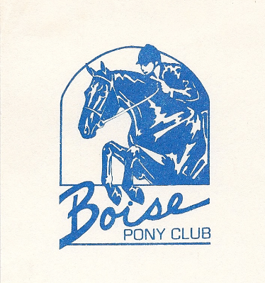
Boise Pony Club
Developing Youth in Leadership, Stewardship, Sportsmanship and Horsemanship

June 22, 2011
August 15, 2018

To Whom It May Concern

We are members of the Boise Pony Club, a local chapter of the United States Pony Club. The mission of Pony Club is to provide a program for youth that teaches riding, mounted sports, and the care of horses and ponies, thereby developing responsibility, moral judgment, leadership and self-confidence. In order to provide riding and competition opportunities, as well as instruction, our club relies on volunteers and fundraisers. On October 27, 2018 we will be hosting a Friends & Family Trivia Night with a silent auction. The event will encourage our non-equestrian friends and family members to participate in a fun-filled trivia challenge and potluck dinner. We are soliciting donations from area businesses for auction items. If your organization is interested in donating to this project we would greatly appreciate your contribution. This letter and our letter of Thank You indicating your exact donation are sufficient documentation of your donation for tax purposes. Our IRS 501(c)(3) tax number is 82-0386225.

All proceeds from the auction will be used by the club to pay for mounted instruction, rating examinations and our portion of the regional competition rallies. If you wish to have further information about the Boise Pony Club, please contact our District Commissioner, Kasey Krone at 208-921-2577. Thank you in advance for your consideration and support.

Sincerely,

Kasey Krone DC
Boise Pony Club

